Tips for participating in Zoom meetings
You will need the following:
- An internet connection – broadband wired or wireless (3G or 4G/LTE)
- Speakers and a microphone – built-in or USB plug-in or wireless Bluetooth
- A webcam or HD webcam - built-in or USB plug-in
Supported Browsers
- Windows: IE 11+, Edge 12+, Firefox 27+, Chrome 30+
- Mac: Safari 7+, Firefox 27+, Chrome 30+
- Linux: Firefox 27+, Chrome 30+
How to join a Zoom meeting:
Your teacher/instructor/host will send you an invitation to the planned class. In that invitation there are two ways to connect using your computer. You can click on the url link which should directly open up to the meeting.
Vicki de Klerk Rubin is inviting you to a scheduled Zoom meeting.
Topic: Level 3 test discussion
Time: Mar 26, 2020 06:00 PM Amsterdam
Join Zoom Meeting
https://zoom.us/j/4876265121 (EXAMPLE URL LINK)
Meeting ID: 487 626 5121 (EXAMPLE MEETING ID)
One tap mobile
+13462487799,,4876265121# US (Houston)
+16699006833,,4876265121# US (San Jose)
International dial-in numbers: https://zoom.us/u/abH1IVis7f
Meeting ID: 487 626 5121 (EXAMPLE MEETING ID)
If you have never used Zoom before, you can download the software as a first step on www.zoom.com. It is possible to download it in your preferred language.
If you don´t want to download the Zoom app, you can go to www.zoom.us and click on JOIN A MEETING. The quality and functionality are slightly lower than within the app.
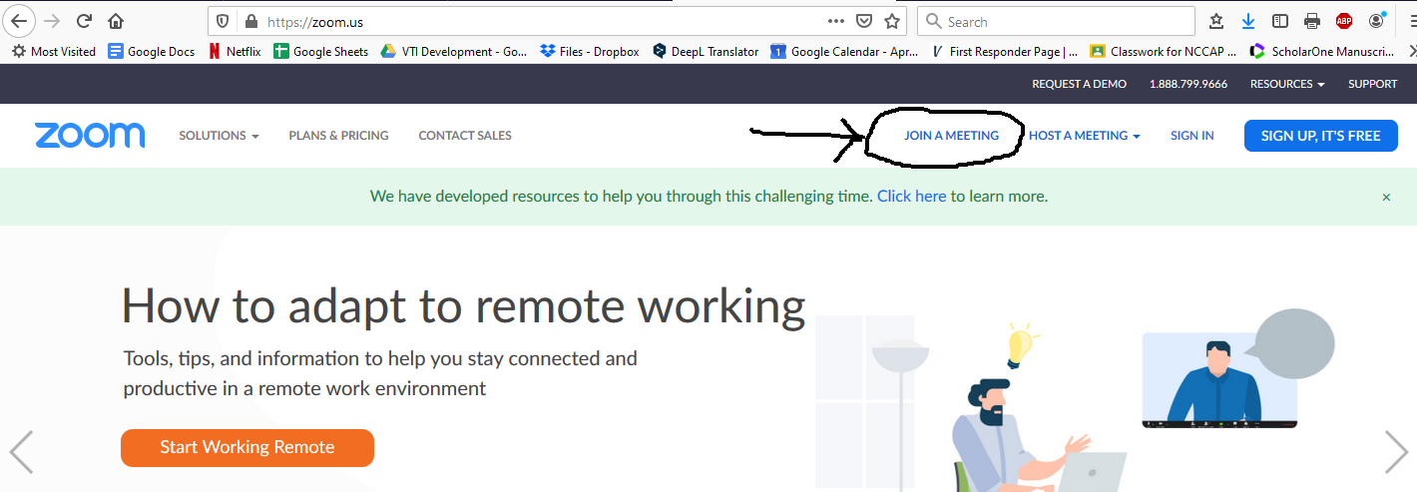

A screen will open up where you can enter the Meeting ID that was sent in the invitation and press JOIN.
You will be asked to OPEN LINK
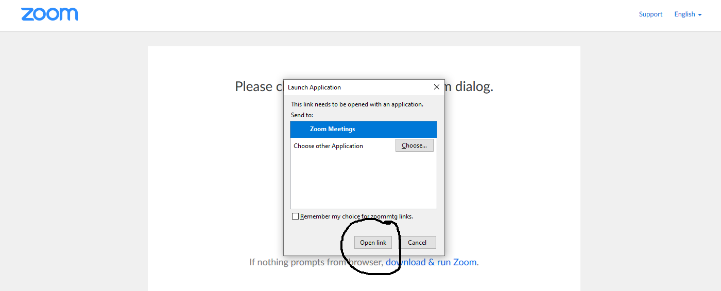

Next you will be asked to join with or without video. Please choose JOIN WITH VIDEO.
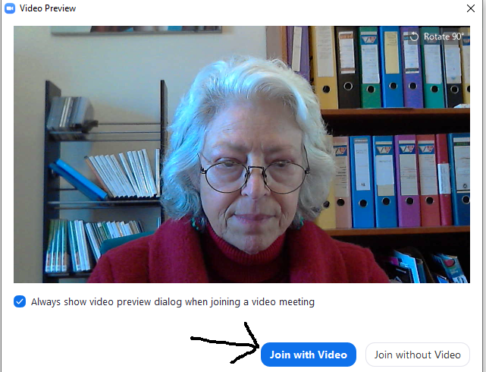

The next screen will connect your audio. If you have a microphone connected to your computer, press JOIN WITH COMPUTER AUDIO. If your connection is not good, you can always use your phone to call into the meeting. The available telephone numbers will be included in your invitation. In that case, click PHONE CALL.
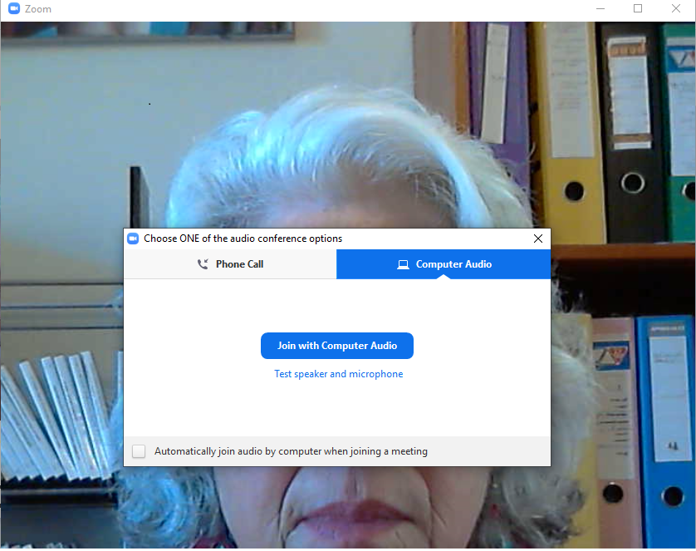

To improve your meeting experience
Test the connection at least 15 minutes before the planned start of the class, this allows speakers to troubleshoot the technology and avoid sound and/or video problems that could arise.
For those unfamiliar with Zoom, run your mouse on the bottom or top of your screen, a series of icons should show up.
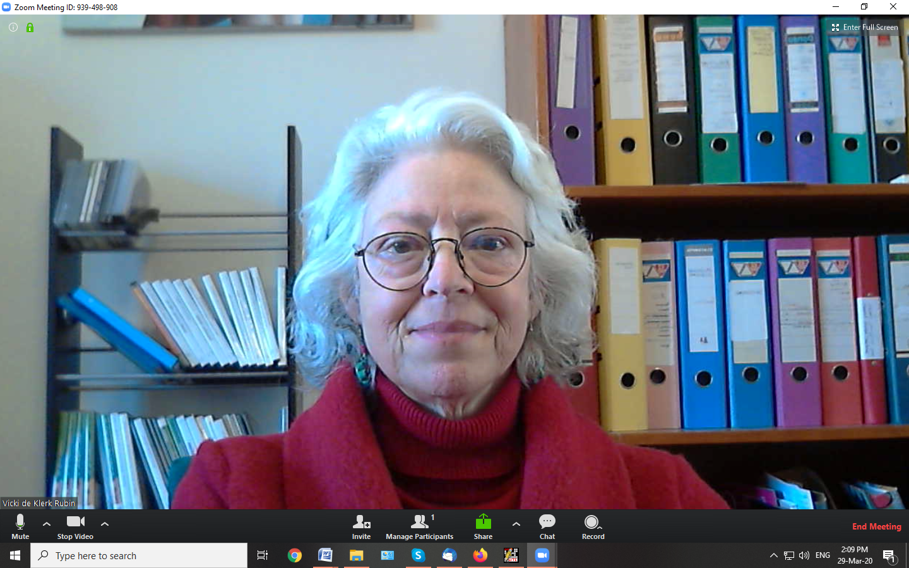
Icon description from left to right:
- Microphone - by clicking on the mic, you can mute your microphone. The carrot to the right opens up your sound settings. If you can't hear the teacher or no one can hear you, you may need to help your computer identify the microphone and speakers. Finally, if you are on mute, you can unmute yourself for a short period of time by pressing on the space bar. If you look at your picture, in the lower left corner you can see if you are muted or not. There will be a red diagonal line through your name.

- Video camera - by clicking on the camera icon you can shut off your camera so no one sees you. The carrot to the right opens up your video settings. If your camera is not connected to the Zoom app, you may need to adjust these settings.

- Invite icon allows you to invite others to this meeting - this is for the meeting host.
- Participants is also for the meeting host.
- Share allows you to share your screen with everyone in the meeting.
- Chat will open a column to the right for exchanging typed messages either to everyone or to just one person. If you have a question or comment and do not want to disturb the class, you can type your message and send it to the host. Remember to press enter after typing your message in order to send it.
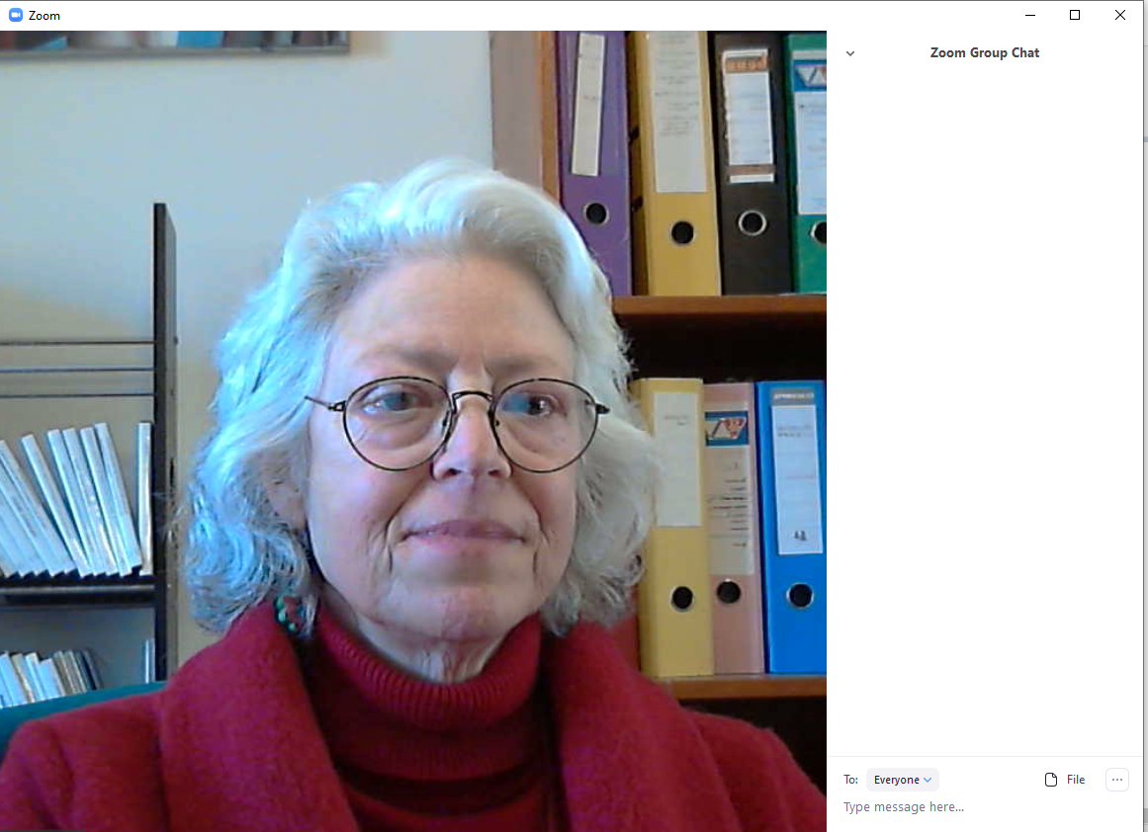

- Record - the host can record the meeting if desired and everyone agrees.

- End meeting - at the end of the meeting, click on this to exit the meeting and close the Zoom app.
At the top of your screen, when you run your mouse over the top, right corner, you will see either Gallery view or Speaker view. Gallery view will allow you to see everyone in the meeting. Speaker view will allow you to see only the person who is speaking.

It is polite to mute your sound when you are listening.
Try not to talk when others are talking; put up a hand and the teacher can give you the nod.
Telephones and other applications on your computer should be turned off and background noise should be minimized.
Want to learn more? Visit YouTube for in-depth tutorial videos here: https://www.youtube.com/playlist?list=PLKpRxBfeD1kEM_I1lId3N_Xl77fKDzSXe

